Tabla de lógica de Adrián Gómez

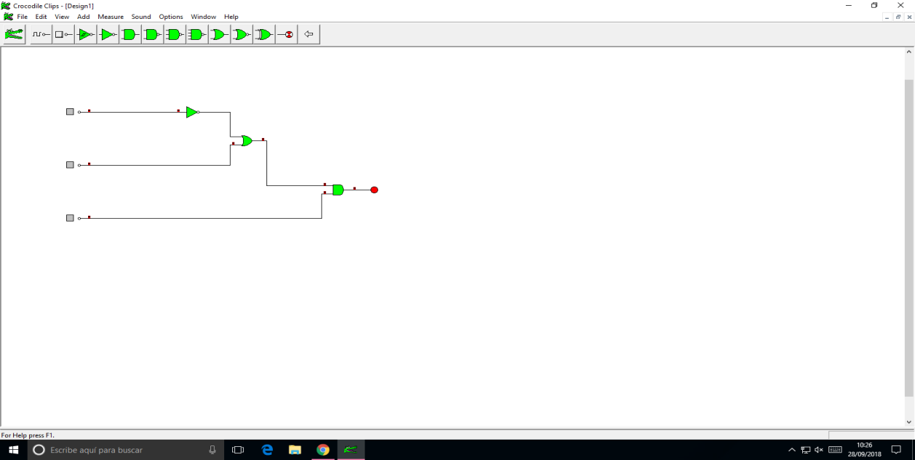

**TABLAS LÓGICAS DEL CIRCUITO:**

|  |  |  |  |  |
| --- | --- | --- | --- | --- |
| **A** | **B** | **C** | **SALIDA** | |
| 0 | O | 0 | 0 |
| 0 | 0 | 1 | 1 |
| 0 | 1 | 0 | 0 |
| 0 | 1 | 1 | 1 |
| 1 | 0 | 0 | 0 |
| 1 | 0 | 1 | 0 |
| 1 | 1 | 0 | 0 |
| 1 | 1 | 1 | 1 |

**FUNCIONES:**

Salida: (á+b).c

Salidas: á.´b.c + a.b.c + á.b.c